

Assessment of Blindness Compensatory Skills
Among Visually Impaired Students of Classes 4 & 5
in Government Schools Under SSA

--- A Research study---

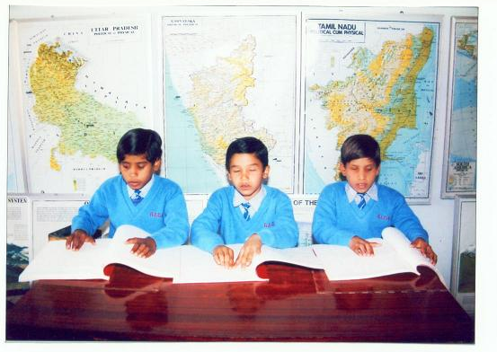

SPONSORED BY
THE ASIAN BLIND UNION

CONDUCTED AND PUBLISHED BY
ALL INDIA CONFEDERATION OF THE BLIND
SECTOR-5, ROHINI, DELHI, INDIA

2009

Acknowledgement

As we conclude this important project, it is our very pleasant responsibility to place on record our deep appreciation and gratitude for all our friends and well-wishers, who have lent us their valuable co-operation and support in conducting different activities.
First and foremost, we must acknowledge the debt of gratitude we owe to the Asian Blind Union for appreciating the importance and relevance of a project of this nature and providing us valuable financial assistance for the purpose.

Our sincere gratitude is due to the officers of the Union Ministry of Human Resource Development, Department of School Education and Literacy for coming to our help and responding favourably to our project and commending it to the concerned State-Project Directors.

We are also most thankful to the State Project Directors, in-charge of SSA Scheme for granting us necessary permission to conduct the study under the project in the government schools under their control. But for their timely help, it would have been extremely difficult for us to go through with the project activities.

Our thanks also go out to the heads and concerned teachers of all of the 149 government schools we contacted for carrying out the study. We quite appreciate the multifarious preoccupations of these heads and teachers and earnestly recognize the support provided to us.

We can not forget the visually impaired children who participated so actively in the project and took the various tests prepared therein for assessing their efficiency levels in reading, writing, arithmetic work as also orientation and mobility. The positive response given by these children to our endeavours has indeed been most heart-warming and we thank each one of them.

The principals and teachers of mainstream language schools in Delhi have also proved a resource of great significance. They enabled us to identify and select passages for our reading and writing tests in Bengali, Gujarati, Marathi, Malayalam and Tamil and also undertook so willingly the task of evaluating students’ responses and we thankfully acknowledge their help. My colleagues on our Committee of Experts deserve a big “Thank you” for their valuable co-operation in overseeing the task of preparing test material including suggesting exercises for arithmetic and O.&M. test. Last but by no means least, we wish to place on record our sincere appreciation for the hard work put in by our Confederation staff in preparing the text of the report and diligently proof reading it.

It is our earnest hope that this project would be viewed by all concerned in its proper perspective and would be of help in enabling visually impaired children to receive meaningful and quality education in the concerned basic and core skills covered under the project.

--------A.K. Mittal

Contents

Chapter Page

Chapter-1
Introduction 1
1.1 Education for the Blind in India—
Some Important Milestones: 1887-2009 1
1.2 The Scenario Today 5

Chapter-2
About the Study 12
2.1 Statement of the Problem 12
2.2 Rationale 13
2.3 Objective 14
2.4 Duration 15
2.5 Funding 15

Chapter-3
Methodology 16
3.1 Design 16
3.2 Sample 16
3.3 Locating the Sample 17
3.4 Tools 18
3.5 Investigators 19

Chapter-4
Data-Analysis and Results 22
4.1 Collection of Data 22
4.2 Information about Textbooks, Assistive
Devices and Special Teachers 27
4.3 Test Performance 33

Chapter-5
Summary and Recommendations 42
5.1Summary 42
5.2 Limitations 44
5.3 Findings 45
5.4 Recommendations 46
5.5 Summing Up 50

List of Tables

S. No. Name of Table Page No.

- Total Number of Visually Impaired Children in
India According to School-Age Years 6
- Number of Visually Impaired Children Attending
Educational Institutes, According to School-Age Years 8

- Statewise Distribution of Blind Children at
Government Schools Under SSA 10
4. Statewise Number of Districts and Schools 24
5. Statewise Distribution of the Sample According to
the Visual Status 26
6. Statewise Information on Braille Textbooks 28
7. Statewise Information on Assistive Devices 30
8. Statewise Information about Number of Schools
with Special Teachers 32
9. Distribution of Mean Scores Statewise—Reading
and Writing 34
10. Distribution of Mean Scores Statewise—Arithmetic 36
11. Distribution of Mean Scores Statewise— Orientation
& Mobility 38
12. Summary of Mean Scores Testwise. 40

List of Annexures

Annexure - A: Letter from the Union Ministry of Human
Resource Development 51

Annexure- B: Copies of Test-Papers 53

Annexure -C: Personal Data-Sheet 61

Annexure -D: Instructions for Investigators 63

